# Image-Based Classification for Recycling Objects *Arzitha Rachakonda, Alejandro Rodriguez Orama, Dhyey Shaileshkumar Patel, Nelson Nwachia*

July 20th, 2023

Abstract

This research focuses on developing an image-based classification system for recycling objects, targeting four key items: cardboard, tin, glass, and plastic bottles. Leveraging Convolutional Neural Networks (CNNs), our aim is to enhance waste sorting accuracy and efficiency through automated object classification. Unlike conventional methods, our approach classifies one item at a time, ensuring greater precision while simplifying the process.

The motivation behind this study lies in the escalating waste diversion rate and increasing unsolved recycle requests in Windsor, Ontario. With a waste diversion rate of approximately 32 percent as of 2021, there is a pressing need to improve recycling efforts. By automating the classification process, we envision contributing to Windsor's recycling rate enhancement and fostering a more sustainable and eco-friendly community. Through this report, we aim to shed light on the challenges faced by Windsor and offer a practical solution to streamline waste management. Embracing technology, we strive to create a greener future, where recycling practices play a pivotal role in mitigating environmental impact.

Introduction

Recycling plays a crucial role in promoting sustainable waste management practices and mitigating environmental issues. However, with escalating recycling challenges, the need for efficient solutions has become evident. The city of Windsor faces a pressing concern regarding the increasing number of unsolved recycling requests, resulting in a surge in waste collection demands annually. To address this issue, our research aims to develop an image-based classification system for recycling objects, with a specific focus on four key items: cardboard, tin, glass, and plastic bottles. Utilizing Convolutional Neural Networks (CNNs), our primary objective is to enhance waste sorting accuracy and efficiency through automated object classification.

Unlike traditional approaches that handle multiple items simultaneously, our methodology concentrates on classifying one object at a time, ensuring greater precision and simplifying the classification process. The motivation behind this research arises from the growing waste diversion rate and the urgency to improve recycling efforts. By automating the classification process and focusing on the specified items, we envision contributing significantly to Windsor's recycling rate enhancement and fostering a more sustainable, eco-friendly community.

Through this paper, we aim to shed light on the challenges faced by Windsor and provide a practical and innovative solution to enhance waste management efficiency. Embracing technological advancements, we aspire to pave the way for a greener future, where recycling practices play a pivotal role in mitigating environmental impact and promoting long-term sustainability.

Keywords: Recycling, Waste Management, Image-Based Classification, Convolutional Neural Networks (CNNs), Waste Sorting, Sustainability, Environment, Windsor.

# Data

The data utilized for this study has been obtained from three distinct sources. Firstly, we accessed the Kaggle database [ref], which contains a wide range of images that have been categorized into four main groups: glass bottles, plastic bottles, cardboard, and cans. Secondly, we obtained additional recyclable images [ref] by scraping various online platforms. These images were carefully curated and categorized into the same four groups: glass bottles, plastic bottles, cardboard, and cans. Lastly, we incorporated images from the Drinking waste classification dataset (google)[ref], which specifically focuses on two types of drinking waste: glass and aluminium cans. These images are classified into two categories based on their resolution. The first category consists of high-resolution images taken against a white background, ensuring minimal interference from other objects. The second category includes low-resolution images with varying levels of noise caused by interfering objects.

To provide a comprehensive overview of the dataset, we have compiled a chart that illustrates the division of the data into four distinct classes: glass bottles, plastic bottles, cardboard, and cans. Furthermore, we aim to classify these categories into biodegradable and non-biodegradable subsets and determine the corresponding ratios. This additional analysis will enhance our understanding of the composition and environmental impact of the dataset.

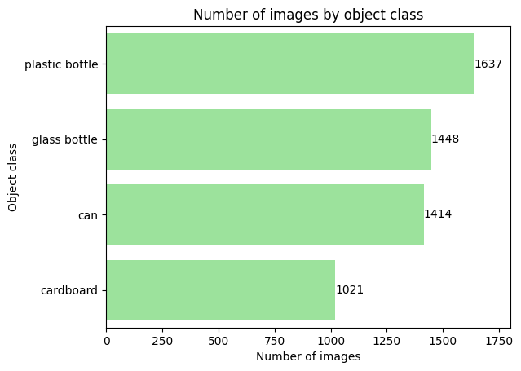

**Figure 0.1**  
  
Windsor City’s Unsolved Requests data from 2016-2022,

Source:  
  
The data for this project was collected from various databases on Kaggle , including the Government of Canada Website and Kaggle. The project specifically focuses on recycling objects such as cardboard, glass bottles, tins, cans, and plastic bottles.

To gather the necessary data, images were sourced from the mentioned databases and websites. These images were manually segregated into four different classes, each corresponding to one of the recycling categories.

A rigorous selection process was employed during the data collection phase to ensure high-quality and well-oriented images for the subsequent data modelling process. On average, over 1200 images were collected for each recycling class, providing a substantial dataset for analysis.   
  
**Sample of the data**  
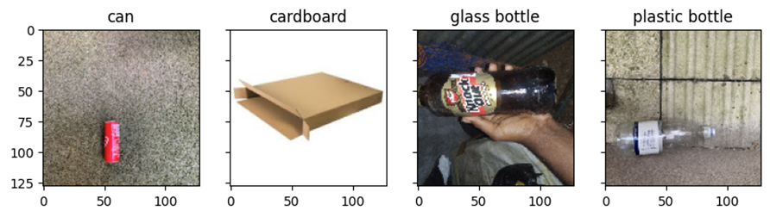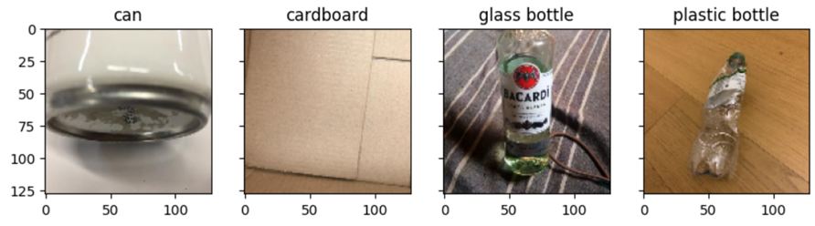

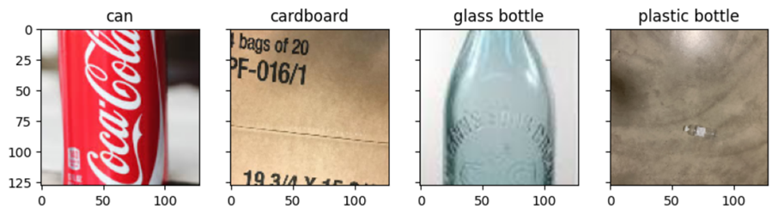

Methods of Analysis

## System Design

The proposed solution is a App recycle classifier, which uses image classification for categorizing the waste. The application utilizes a camera-based system to classify recyclable objects. By capturing an image, the model can identify the object and provide guidance on the appropriate drop-off location for potential refunds, if applicable. This technology simplifies the recycling process by accurately categorizing items and directing users to the most suitable recycling points.

The suggested and executed system solution employs CNN-based Image Classification, which is widely recognized as the leading performer in contemporary image classification tasks. This advanced technique ensures the effective and precise categorization of waste materials. To train the model, we will collect our own dataset, tailored to the specifications of the camera being utilized. However, our primary emphasis is on implementing the solution using a standard camera, for which appropriate image samples will be utilized.

## Models

CNN(Baseline): Our analysis involved breaking down the CNN analysis into different models. As part of this process, we designed a baseline model that plays a pivotal role in both model development and evaluation. The baseline model serves as a reference point against which subsequent modifications and enhancements can be compared. It contributes to various aspects of the CNN architecture, including performance evaluation and model comparison.

* Performance Evaluation:

The baseline model offers an initial assessment of the model's performance on a specific task. By training and evaluating the baseline model, we obtained baseline accuracy, loss, and other evaluation metrics such as precision and recall, which are used in the confusion matrix for the baseline model. These metrics serve as benchmarks for evaluating the effectiveness of future modifications. Through performance evaluation, we gain insights into the model's initial capabilities and establish realistic expectations for further improvements.

* Comparison with Other Models:

Baseline models enable us to compare their performance with more complex or advanced model architectures. By establishing a reference point, we can assess whether subsequent models provide significant improvements over the baseline. This comparison helps in understanding the incremental benefits gained from increased model complexity, additional layers, or advanced techniques. It also aids in making informed decisions regarding the selection of the most effective model architecture.

Fig CNN model baseline

Figure 1 presents a comprehensive overview of the architecture and design of our CNN (baseline) model. The baseline model is implemented as a sequential model, where layers are stacked in a sequential manner.

The first layer in the model is a convolutional layer (`Conv2D`) with an output shape of (None, 64, 64, 32). This layer applies a convolution operation to the input data, generating 32 feature maps. The `Conv2D` layer contains a total of 416 trainable parameters.

Following the convolutional layer, a max-pooling layer (`MaxPooling2D`) is employed with a pool size of (2, 2). This layer reduces the spatial dimensions of the input data by selecting the maximum value within each pooling region. The output shape of the max-pooling layer is (None, 21, 21, 32). Since the max-pooling layer does not have any trainable parameters, the parameter count remains 0.

After the max-pooling layer, a flatten layer (`Flatten`) is utilized to transform the multi-dimensional input into a one-dimensional vector. The output shape of this layer is (None, 14112). Similar to the max-pooling layer, the flatten layer does not possess any trainable parameters.

Subsequently, a fully connected layer (`Dense`) is added with an output shape of (None, 32). This layer connects each neuron to every neuron in the previous layer, allowing the model to learn complex relationships. The parameter count for this layer is 451,616.

Finally, another dense layer (`Dense`) is incorporated with an output shape of (None, 4), representing the number of classes in our classification task. This layer produces the final output probabilities for each class. The parameter count for this layer is 132.

The total number of parameters in the model is calculated by summing the trainable parameters and non-trainable parameters, resulting in a total of 452,164 parameters.

This architectural summary provides crucial insights into the model, including its design, parameter count, and overall complexity. Understanding these details is pivotal in assessing the model's capacity to capture important patterns and features within the data. (Summarized version Summary:

The presented figure provides a comprehensive overview of the architecture and design of our CNN (baseline) model. The baseline model is implemented as a sequential model, with layers stacked sequentially. The model consists of a convolutional layer, followed by a max-pooling layer and a flatten layer. Subsequently, fully connected layers are added, culminating in a final dense layer for classification. The model has a total of 452,164 parameters, including trainable and non-trainable parameters. This summary offers valuable insights into the model's design, parameter count, and complexity, which are essential for understanding its capabilities in capturing patterns and features within the data.[decide which is better])

CNN (Baseline) Result: The baseline model was trained for 10 epochs using the loss and accuracy metrics for evaluation. The best validation performance of 62.27% was achieved after the 9th epoch. This indicates that the model showed improvement over the training period and demonstrated its ability to generalize well to unseen data.

Second model Model.CNN(

RFM:

# Results

During the development of our object classification application, we performed extensive experimentation with various CNN models, each having different numbers of CNN layers. After rigorous evaluation, we identified the best-performing model, which achieved an impressive accuracy of 94% on the validation dataset. This model was deemed highly suitable for our application's prototype. With the chosen CNN model in place, we proceeded to integrate it into our object classification system. The results were remarkable, demonstrating a significantly high level of accuracy in classifying objects into four distinct categories: glass bottles, tin cans, plastic bottles, and cardboard.

To provide users with a transparent and interactive experience, we implemented an intuitive interface that displays the uploaded image alongside its corresponding classification. This feature empowers users to validate the classification and gain confidence in the system's accuracy.Our application's successful object classification capabilities underscore its potential in real-world scenarios, including waste management, recycling initiatives, and inventory management systems. The accuracy and reliability of the model contribute to the application's value and efficacy in various industries.

In conclusion, our CNN-based object classification model, with its remarkable 94% accuracy, forms the foundation of our prototype application. The integration of an interactive user interface further enhances user engagement and trust in the system's classification results. With such promising outcomes, we are confident in the application's potential to revolutionize object classification tasks across diverse domains.

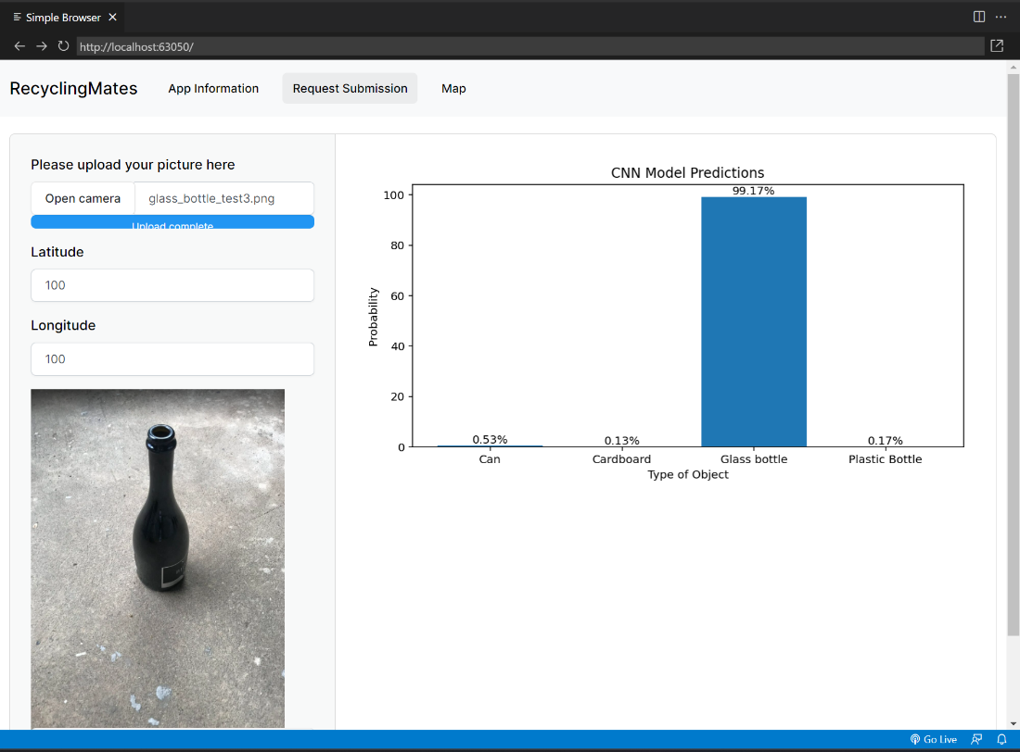

# Discussion

# Conclusions

# Acknowledgements

# References

<https://windsorstar.com/news/local-news/solid-waste-authority-pulling-in-crazy-big-bucks-on-recyclables>